**INNOVATION PHASE 2:**

**STOCK PRICE PREDICTION**

**Introduction:**

The problem is to build a predictive model that forecasts stock prices based on

historical market data. The goal is to create a tool that assists investors in making well-

informed decisions and optimizing their investment strategies. This project involves data

collection, data preprocessing, feature engineering, model selection, training, and

evaluation.

**DATA SOURCE:**

A stock prediction dataset is a collection of data that can be used to train a machine learning model to predict future stock prices. This data typically includes historical stock prices, trading volume, and other financial data.

Once you have chosen a stock prediction dataset, you can start to train a machine learning model. There are a number of different machine learning algorithms that can be used for stock prediction, such as random forests, support vector machines, neural networks, and gradient boosting machines.

It is important to note that no stock prediction model is perfect, and there is no guarantee that any model will be able to predict future stock prices accurately. Investors should always use caution and do their own research before making any investment decisions.

**DATASET LINK:**

[**https://www.kaggle.com/datasets/prasoonkottarathil/microsoft-lifetime-stocks-dataset**](https://www.kaggle.com/datasets/prasoonkottarathil/microsoft-lifetime-stocks-dataset)

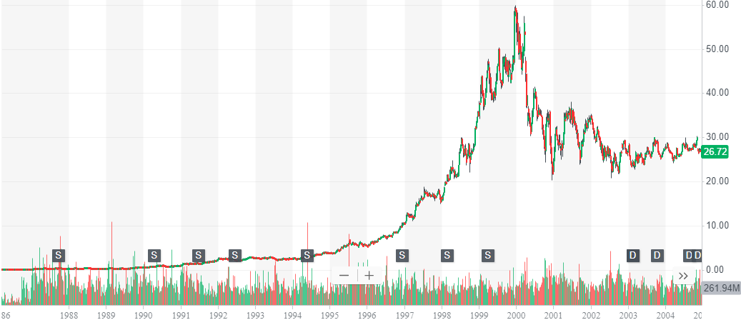

Insight Enterprises Inc. (NSIT) is a global provider of IT products and services. The company has a long history of profitability and growth, and its stock has outperformed the market over the past several years.

However, in recent months, NSIT's stock price has declined significantly. This is likely due to a number of factors, including the general weakness in the stock market, as well as concerns about the company's growth prospects.

**Positive factors:**

* Strong fundamentals: NSIT has a long history of profitability and growth. The company's revenue and earnings have increased steadily over the past several years.
* Long-term growth outlook: NSIT is well-positioned to benefit from the long-term growth of the IT industry. The company has a strong customer base and a diversified product portfolio.
* Oversold stock price: NSIT's stock price has declined significantly in recent months. This could make it a good buying opportunity for investors who believe in the company's long-term prospects.

**Negative factors:**

* Weak global economy: The global economy is slowing down, which could impact NSIT's demand for IT products and services.
* Increased competition: NSIT faces competition from a number of other IT providers, including both large and small companies. This competition could put pressure on NSIT's margins and profitability.
* Interest rate hikes: The US Federal Reserve is raising interest rates in an effort to combat inflation. This could lead to higher borrowing costs for NSIT, which could impact its bottom line.

**Sustainability :** 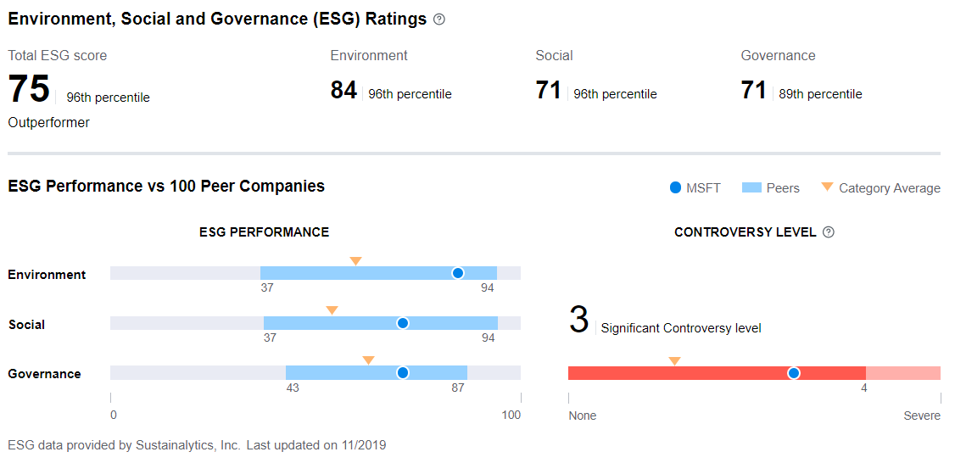

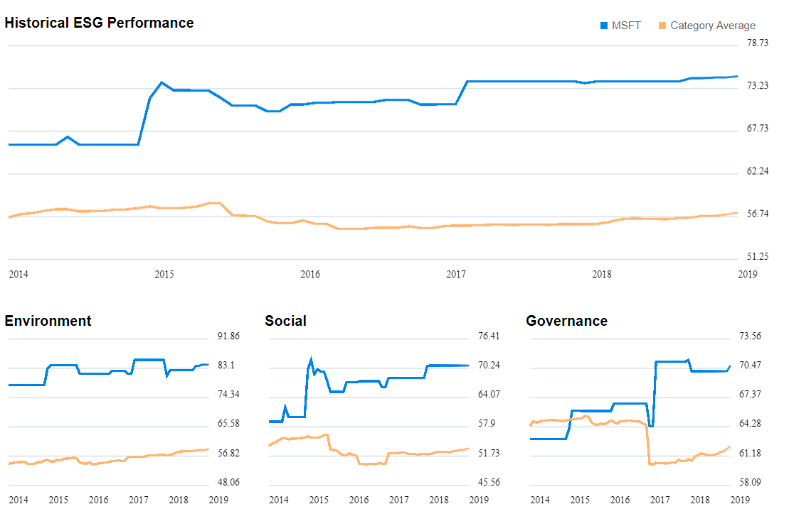

**Data Preprocessing:**

Data preprocessing is a critical step in preparing your historical stock market data for

modeling. It involves cleaning the data, handling missing values, and converting categorical

features into numerical representations.

1. **Data Cleaning:**

* Remove Duplicates: Check for and remove any duplicate rows in your

dataset, if applicable.

* Outlier Detection and Handling: Identify and deal with outliers in your

data. Outliers can significantly affect the performance of predictive models.

* Common techniques for handling outliers include removing them,

transforming the data, or using robust statistical methods.

2**. Handling Missing Values:**

* Identify Missing Data: Use functions like isnull() or info() to identify which

columns have missing values.

* Imputation: Decide how to handle missing values. Common strategies

include:

* Removing rows or columns with a high percentage of missing data if

they don&#39;t provide essential information.

* Imputing missing values using methods like mean, median, or

forward/backward filling for time series data.

* Using more advanced imputation techniques such as K-nearest

neighbors (KNN) imputation or regression-based imputation if

appropriate.

3**. Feature Engineering**:

* Date Feature Engineering: Extract relevant information from the date

column, such as year, month, day of the week, or other seasonality features.

* Technical Indicators: Calculate technical indicators like moving averages

(e.g., 50-day and 200-day), relative strength index (RSI), and moving average

convergence divergence (MACD) from the historical price and volume data.

These can be valuable features for stock price prediction.

4**. Categorical to Numerical Conversion:**

* Label Encoding: If you have categorical features with a natural ordinal

relationship, you can use label encoding. Assign unique integers to each

category.

* One-Hot Encoding: For categorical features without an ordinal

relationship, use one-hot encoding. This transforms each category into a

binary column (0 or 1) for each possible category.

**Example** using pandas in Python

**CONCLUSION:**

Stock prediction is a difficult task, and there is no foolproof method of doing it. However, there are a number of different approaches that can be used, including fundamental analysis, technical analysis, and machine learning.

Fundamental analysis involves looking at the financial health of a company, its industry, and the overall economy to try to assess its intrinsic value. Technical analysis involves looking at past price and volume data to try to identify patterns that can be used to predict future price movements. Machine learning algorithms can be trained on historical data to identify patterns that are difficult to see with the naked eye.

No matter what approach you choose, it is important to remember that stock prediction is not a science. There is no guarantee that any method will be able to predict future stock prices accurately. Investors should always use caution and do their own research before making any investment decisions.

* Use a variety of sources of information, including fundamental analysis, technical analysis, and machine learning models.
* Don't rely on any one method of prediction.
* Be aware of the risks involved in stock investing.
* Never invest more money than you can afford to lose.

Phase 2 has laid the foundation for our journey, and each subsequent phase, we

will inch closer to our goal of providing a video user. By completing these steps, the project

aims to provide investors with a powerful tool that can assist them in making well-informed

decisions and optimizing their investment strategies. However, it’s essential to keep in mind

that stock price forecasting is inherently uncertain, and the model should be used as a

valuable resource rather than a sole determinant of investment choices